**Title:** Lab 6. Introduction to MOSFET

**Name:** Robert Bara **Partner:** Dalton Hamilton, Mohamad Asaf, Abdulaziz Almersi

**General Objective:** The general objective of this lab is to explore the basic functionality of a MOSFET transistor. This is done by examining the DC characteristics of the transistor such as the threshold voltage and regions of operation.

**Background Activities:** MOSFETs are Metal-Oxide-Semiconductor Field-Effect Transistors. MOSFETs accomplish the same job as a component such as a BJT transistor, however, MOSFETs are controlled by voltage rather than current. The MOSFET can be examined as a voltage-controlled switch due to the gate-source voltage controlling the drain-source resistance. The smaller the voltage difference between the gate-source, the higher the drain-source resistance will be, which will allow little to no current flowing through the component. If the voltage difference is higher, then current will flow due to a lower resistance. The advantage to using a MOSFET is that it needs less than 1mA of current to turn on, in comparison to BJT transistors. When handling MOSFETs it is important to keep in mind that a MOSFET is sensitive to damage from static discharge, as well as gate-oxide damage when installing, and thermal run away. MOSFETs can be categorized as NMOS or PMOS depending on how many electrons are doped within the component. The MOSFET can operate within three regions:

1. The cut-off region-occurs when the gate voltage difference is too small to form current, so the transistor acts as if it were off.
2. Triode/Linear Region-occurs when the gate to source voltage is greater than drain to source voltage, in which the current will increasingly flow non-linearly to drain potential.
3. Saturation Region-occurs when the gate to source voltage is larger than the threshold voltage of the MOSFET and the current remains settles as a constant current.

**Procedure**

PARTI A:

Begin by opening the MOSFET Characteristics.ms13 Multisim file which uses an enhancement-mode NMOS in addition to the NI ELVIS II setup.

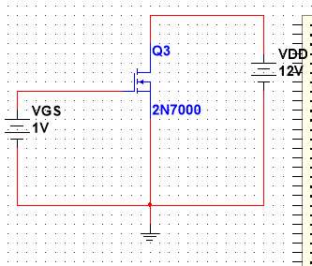

Figure 1. Circuit for PART I

Performa DC Sweep Analysis while the drain voltage is set to 12V. Set the parameters to show the gate voltage VGS, the start value as 0V, stop value as 5V, and the sweep will increment by 0.05V. Generate an output graph so that the source current is upon the Y axis by going to the output tab of the DC Sweep Analysis, and using “Add expression” to add I(VDD) to the output. Run the graph and examine at what voltage will the MOSFET begin conducting current, as well as that is the VThreshold.

PARTI B:

Run another DC analysis so that the drain voltage is graphed upon the X-axis. Set the parameters as follows: start value is 0V, stop value is 5V, increments by 0.05V. Enable the second source to plot the gate voltage and set the parameters so that start value is 0V, stop value is 4V, and it will increment by 0.05V. Add the source current to be graphed upon the Y-axis similarly as done in part I A. Run the graph and examine the characteristics, notice that plots with 0 current flowing are when the gate voltage is less than the MOSFET’s threshold voltage, therefore they are in the cutoff region. Plots that show an increasing current are operating in the linear/triode region, and plots that show a stabilized current is when the MOSFET is within the saturation region.

PART II A:

Build the following circuit to confirm the threshold voltage of the 2N7000 MOSFET:

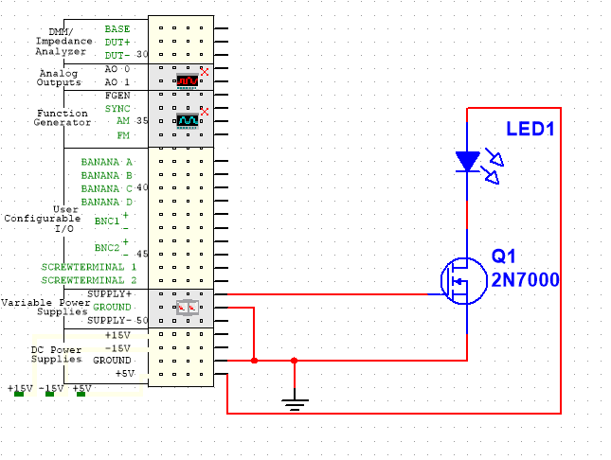

Figure 2. Circuit for PART II

Using the NI Variable power supply, determine the threshold voltage by increasing the Gate’s voltage until the LED lights up. Try to decrease/increase by small voltages until the LED just turns on/off, record the Threshold voltage. Stop the simulation and compare this to the threshold voltage found in PART I. Additionally, determine if this value corresponds to the point where current started to flow.

PART II B:

The next simulation will build upon the circuit built within the last section, however this time the MOSFET will be tested as a switch. Set the NI Variable power supply to 5V and observe the LED, as well as the 0V. Use the digital multimeter to examine how the MOSFET allows current to flow through the Drain-source channel which will turn on the LED. Determine when acting like an open/closed switch, what regions will the MOSFET be operating in. Furthermore, consider if the amount of current flowing from the Variable Power Supply matters for the MOSFET to behave as a switch. Check this by examining how much current flows through the gate.

**Results:**

* 1. **Simulation Results:**

**PART I:**

Below is the generated graph to determine the MOSFET’s characteristic. Notice at approximately 2.24V, current begins to flow, this is the Threshold Voltage.

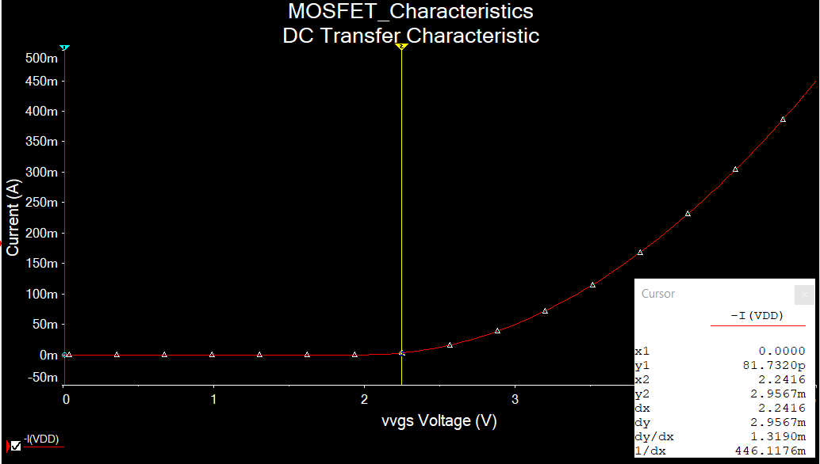

Figure 3. PART I: MOSFET Characteristics

**PART I B:**

Below is the graph comparing the Drain voltage to Source Current. Notice the Triode/Linear Region on the left when current is increasing versus the saturation region on the right when current becomes constant, while the cutoff region resides when current is 0A and holds a voltage less than the threshold voltage for the NMOS.

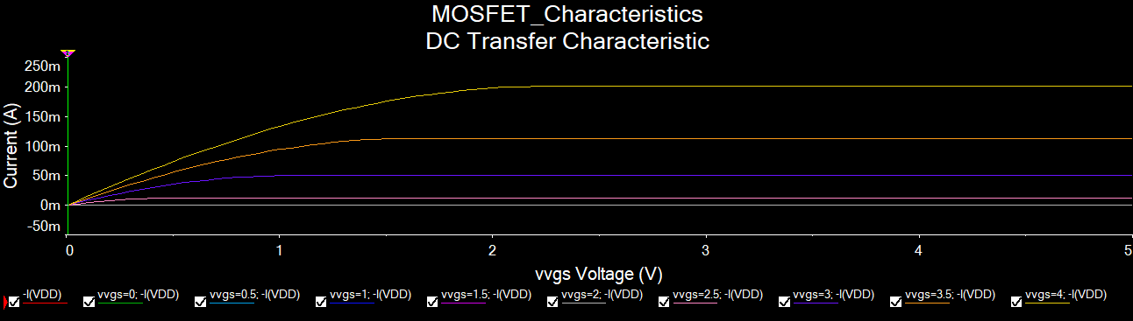

Figure 4. Operation regions of MOSFET due to DC Sweep

**PART II A:**

Below is circuit used to test the threshold voltage and I obtained a Threshold voltage of 2.32V which is fairly close to the estimated value obtained within part I’s sweep of 2.24V:

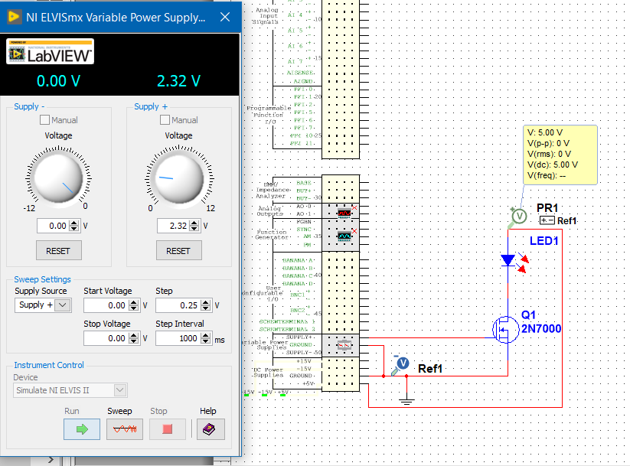

Figure 5. Experimental Threshold Voltage Value

**PART II B:**

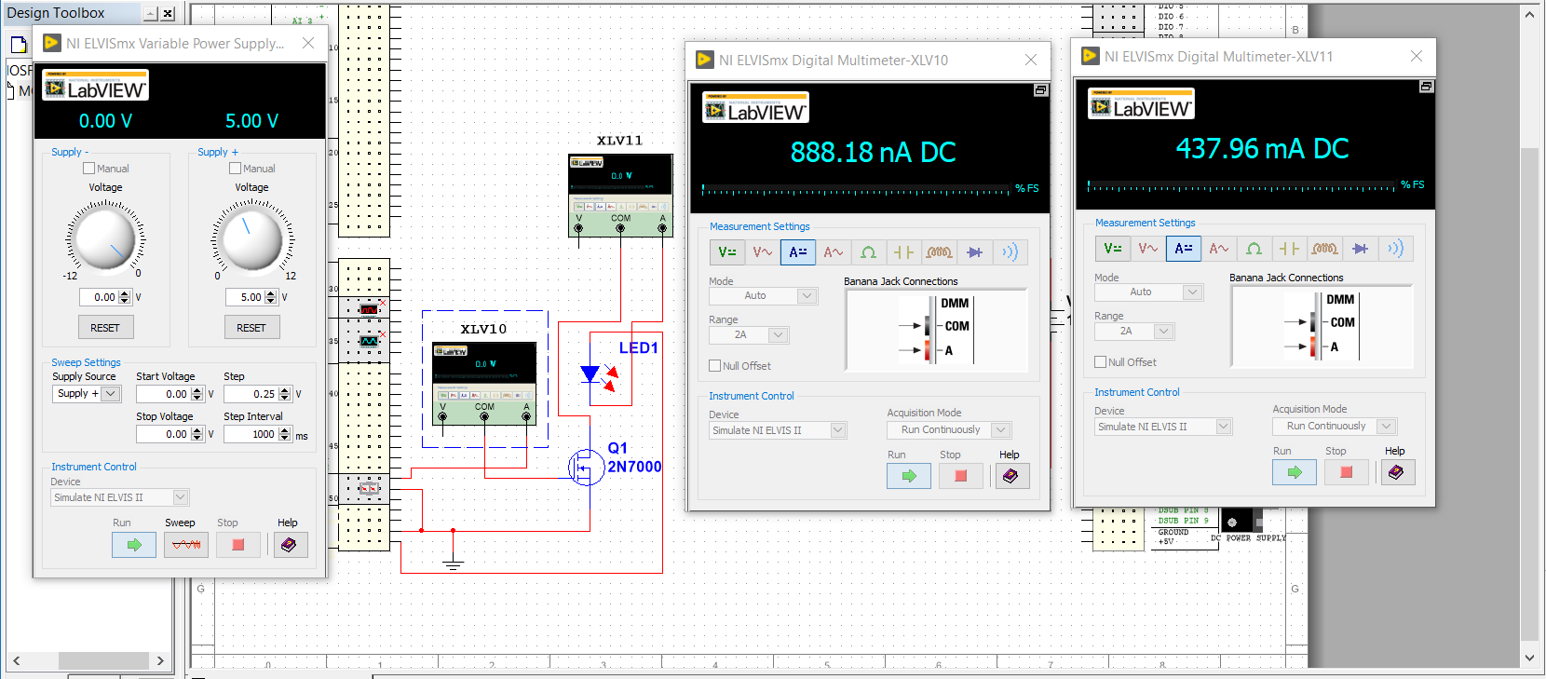

Figure . When the circuit as a switch is on

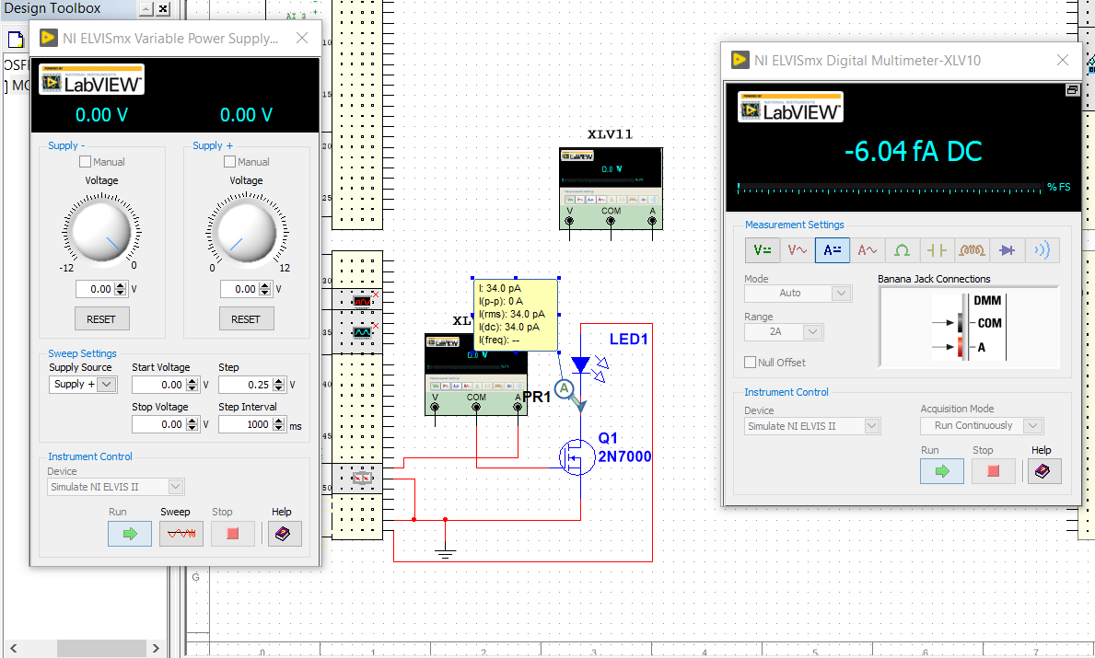

Figure . When the circuit acting as a switch is off

The MOSFET will be on as a closed switch when operating within the linear or saturation region, which is seen by turning on the LED within the circuit since the gate voltage is higher than the threshold voltage. The MOSFET operates as an off open switch within the cut-off region when the gate voltage is less than the threshold voltage and can be seen since the LED never has enough voltage to turn the LED on, therefore the LED remains off. When comparing the current between both simulations, the current is extremely small when the MOSFET is on operating within the linear/saturation regions, however it is a positive value flowing through the gate and increasing just as seen within the graph from the second part of PART I. When the MOSFET is off, the current fluctuates under 0A because the MOSFET is operating within the cutoff region due to the input voltage of 0V being under the threshold voltage of about 2.3V. Even under the threshold voltage the current flowing through the gate from the power supply is measured at 0V, due to the cutoff region:

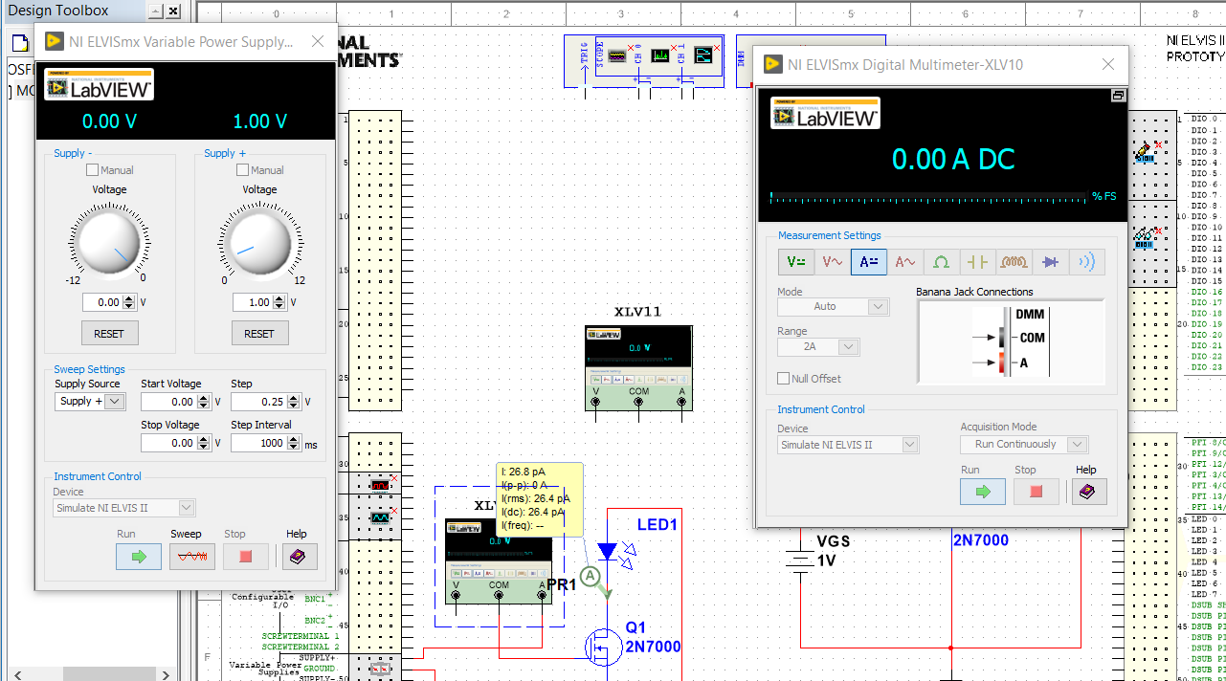

Figure . MOSFET in cutoff region

At 5V, the MOSFET has achieved a saturation region so the current has finished increasing from the linear region and is measured as constant from 5V to 7V:

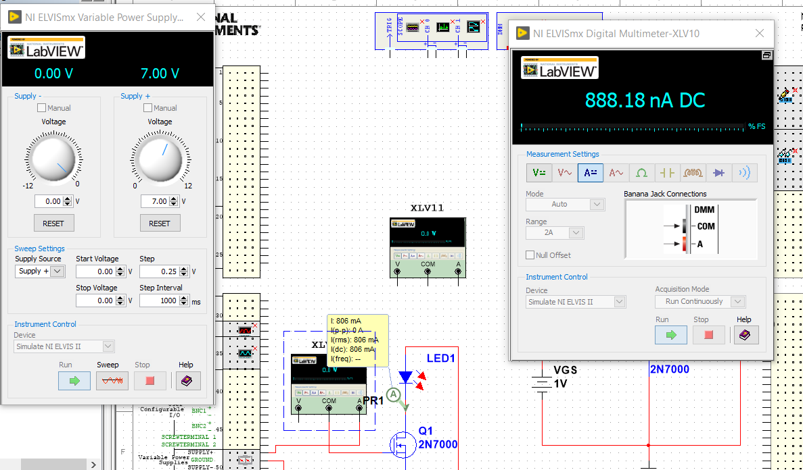

Figure . MOSFET within saturation region

Anything passed 7V will break the MOSFET’s gate oxide and return the device to the cutoff-region since I assume the MOSFET is essentially fried.

1. **Conclusion:**

This lab served as an introduction to MOSFETs by examining one application of how a MOSFET can be used besides amplification, that is to say, as a switch. The MOSFET acting as a switch can also be used for a variety of applications such as creating logic gates. This was accomplished by examining the DC characteristics of the MOSFET as well as the operations regions in which the MOSFET operates in, such as the cutoff, linear, and saturation regions. By performing a DC sweep of the MOSFET, I was able to confirm the threshold voltage of the MOSFET at approximately 2.25~2.3V, additionally I was able to compare the results of the DC Sweep to the results obtained when simulating the MOSFET as a switch, which I further analyzed within my results.